# **PRACTICE REPORT**

# **WEB PROGRAMMING LAB WORKS**

# **MODULE 7**

# **“CSS (*Cascading Style Sheets)*”**



**Assembled by:**

# **ONIC AGUSTINO**

# **L200234275**

**X**

**PROGRAM STUDI TEKNIK INFORMATIKA**

**FAKULTAS KOMUNIKASI DAN INFORMATIKA**

**UNIVERSITAS MUHAMMADIYAH SURAKARTA**

**TAHUN 2024/2025**

**PRACTICE**

1. **Experiment 1 (Border)**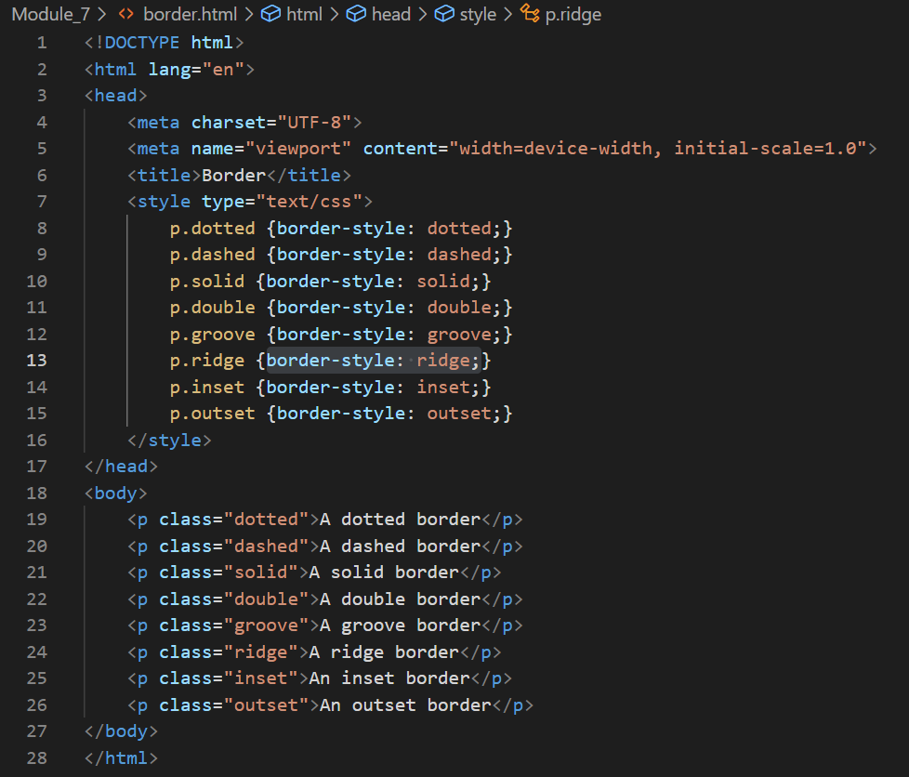

Picture 1.1 The Code.

(Explanation)

This HTML code displays different types of borders on paragraph elements using CSS. In the <style> section, several classes such as .dotted, .dashed, .solid, .double, .groove, .ridge, .inset, and .outset are defined with different border-style properties. Then, inside <body>, some <p> elements are assigned these classes to display various border styles, such as dotted, dashed, solid, double, as well as three-dimensional effects such as groove, ridge, inset, and outset. By using this code, users can understand the different appearance of each border type in CSS. This is useful for improving the design of web pages by varying the border style on certain elements.

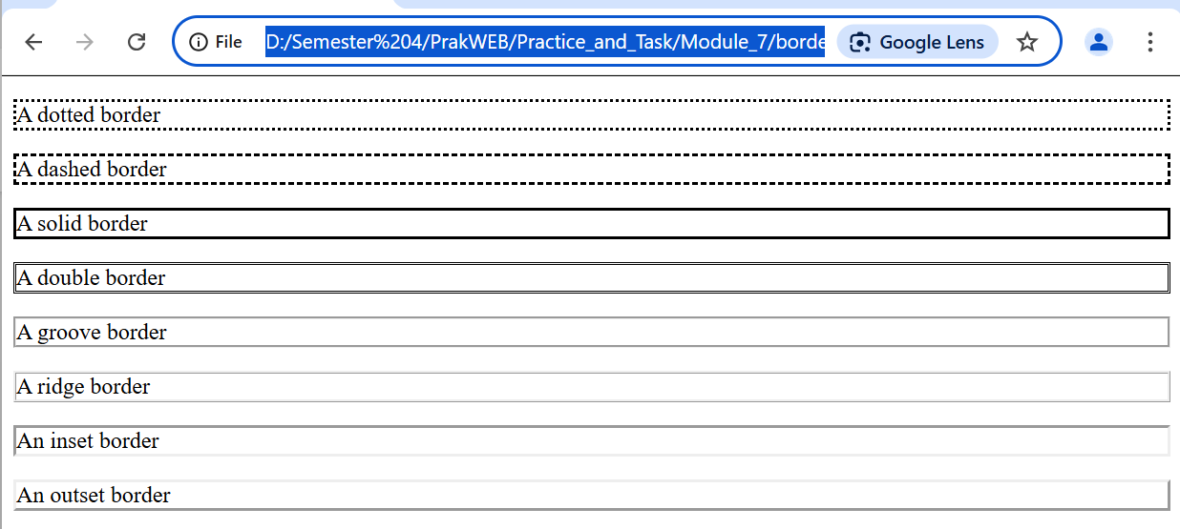

Picture 1.2 The Output.

1. **Experiment 2 (Image)**

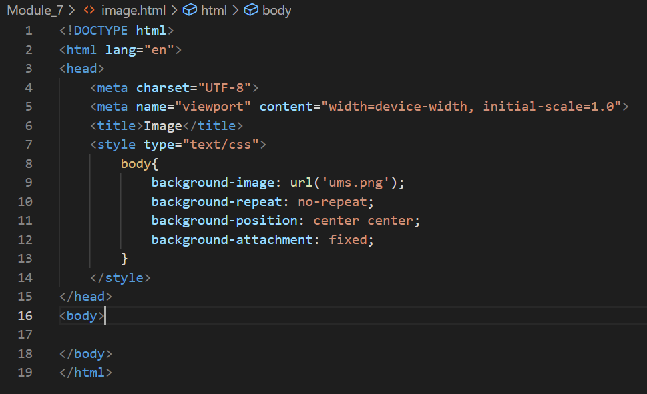

Picture 2.1 the code.

(Explanation)

This HTML code displays a web page with a background image using CSS. In the `<style>` section, the `background-image` property is used to set the `'ums.png'` image as the page background. The `background-repeat: no-repeat;` property ensures that the image does not repeat, while the `background-position: center center;` property keeps the image centered on the page horizontally and vertically. In addition, the `background-attachment: fixed;` property ensures that the background image remains still while the user scrolls the page. With this code, the web page gets a more attractive look with the background image fixed at the center position.

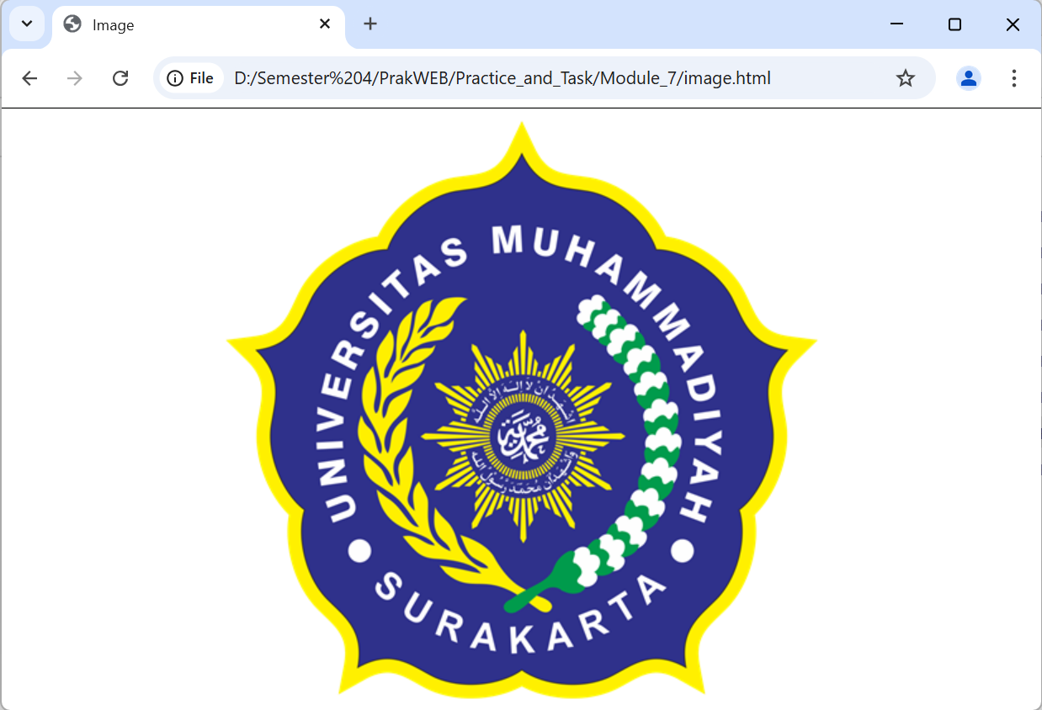

Picture 2.2 the output.

1. **Trial 3 (Shadow)**

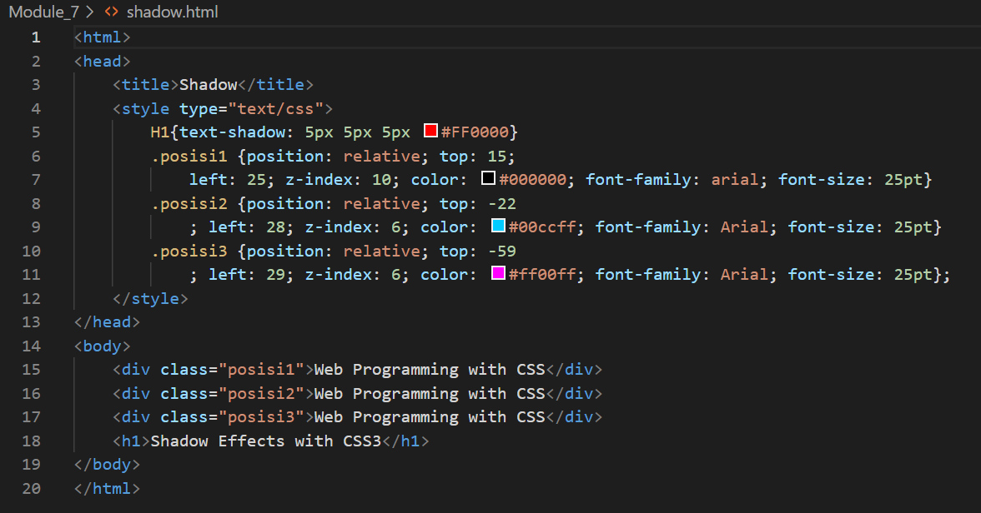

Picture 3.1 the code.

(Explanation)

This HTML code demonstrates the text shadow and relative positioning effects using CSS. The `text-shadow` property is applied to the `<h1>` element, giving it a red shadow effect with a 5px horizontal, vertical, and blur shift. Additionally, three `<div>` elements with the classes `.position1`, `.position2`, and `.position3` have the same text but are positioned slightly differently using `position: relative`, creating a stacked text effect with different colors (black, light blue, and purple). The `z-index` property is used to control the stacking order of the elements so that the text shadow effect is clearly visible.

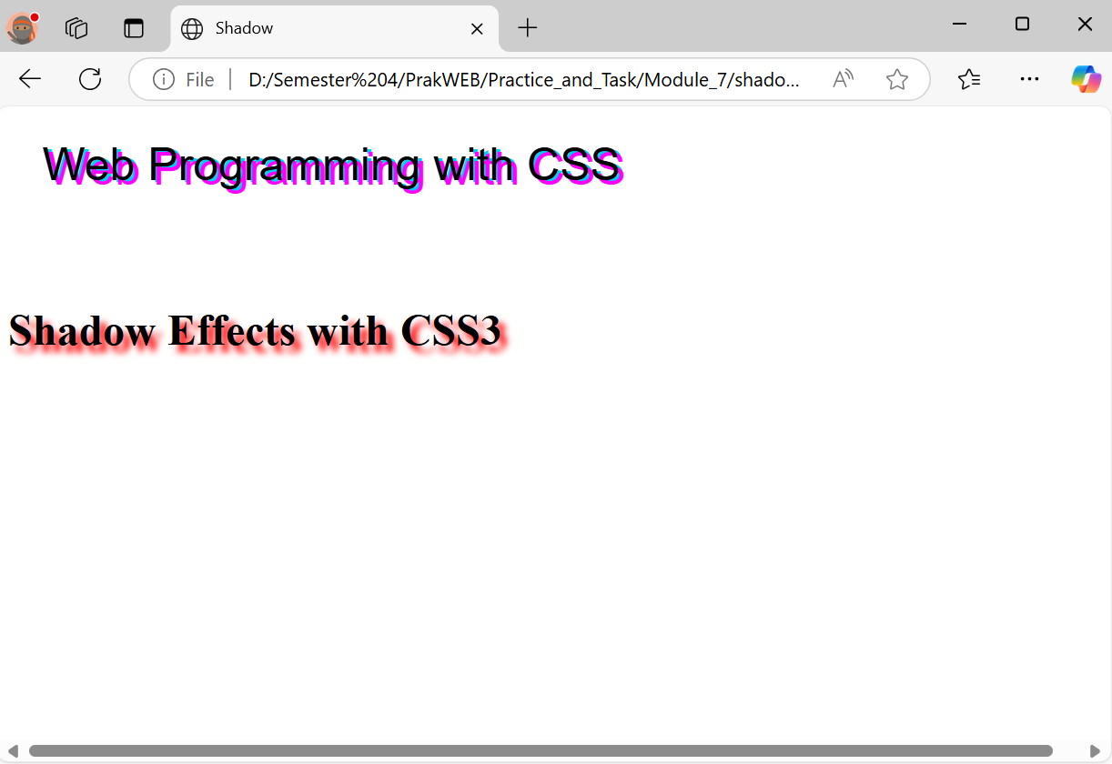

Picture 3.2 the output.

1. **Experiment 4 (Hyperlink)**

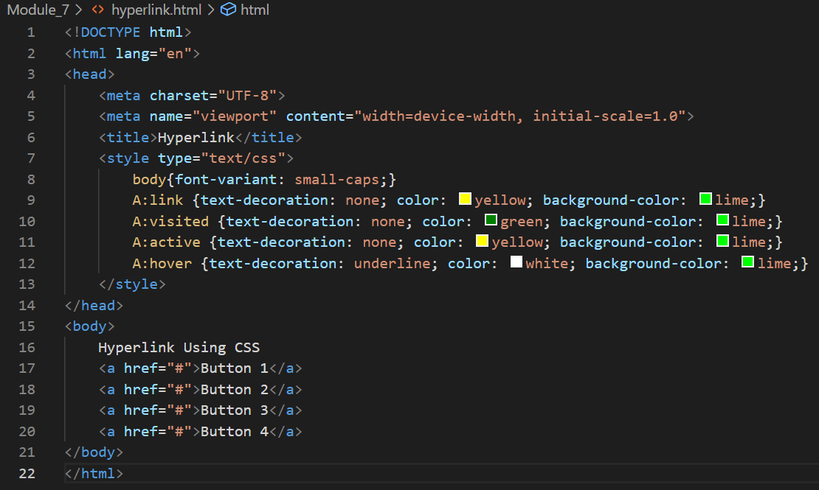

Picture 4.1 the code.

(Explanation)

This HTML code applies special styles to hyperlinks using CSS. The `font-variant: small-caps;` property on the `<body>` element changes all text to small caps. Four CSS rules are applied to the `<a>` element to change the appearance of hyperlinks under various conditions: `A:link` sets the text color to yellow on a green background for unvisited links, `A:visited` changes the text color to green after the link is visited, `A:active` retains the yellow color when the link is clicked, and `A:hover` adds an underline and changes the text color to white when the cursor hovers over the link. With these rules, the appearance of hyperlinks becomes more attractive and responsive to user interaction.

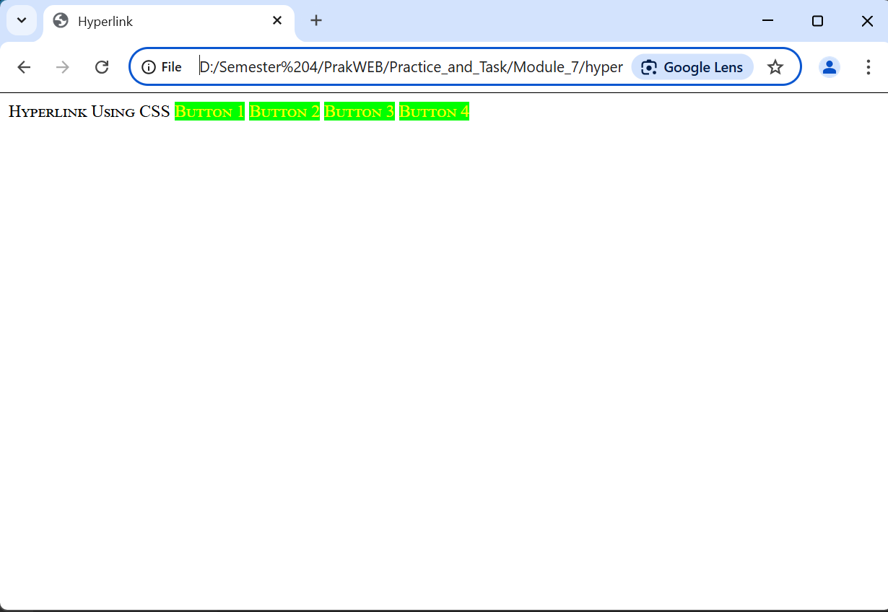

Picture 4.2 the output.

1. **Experiment 5 (Form Using External Style)**

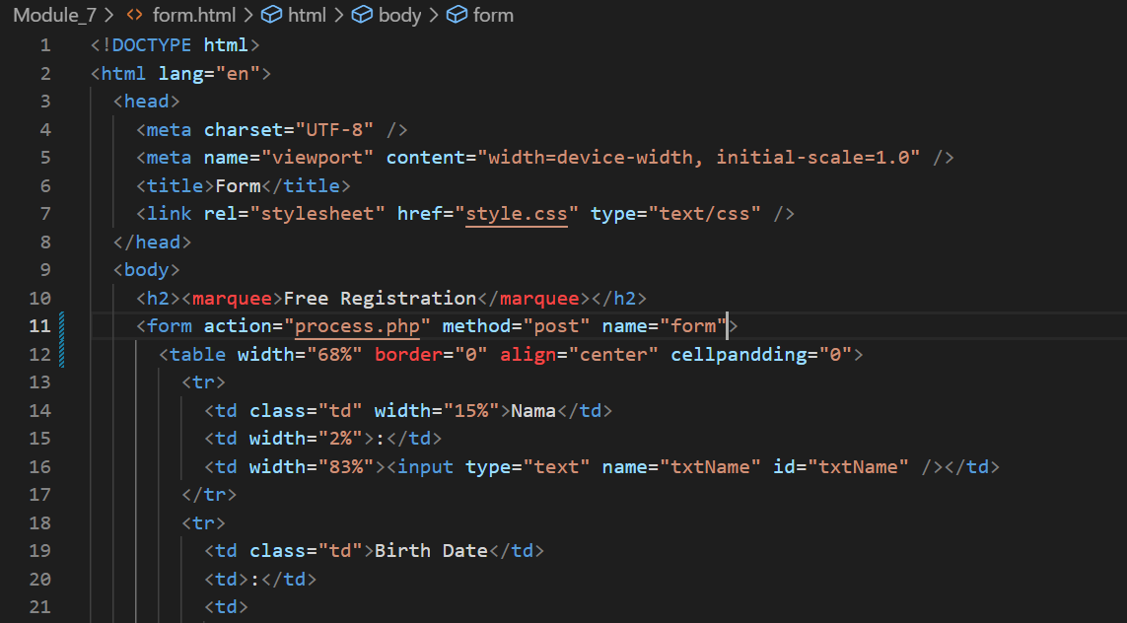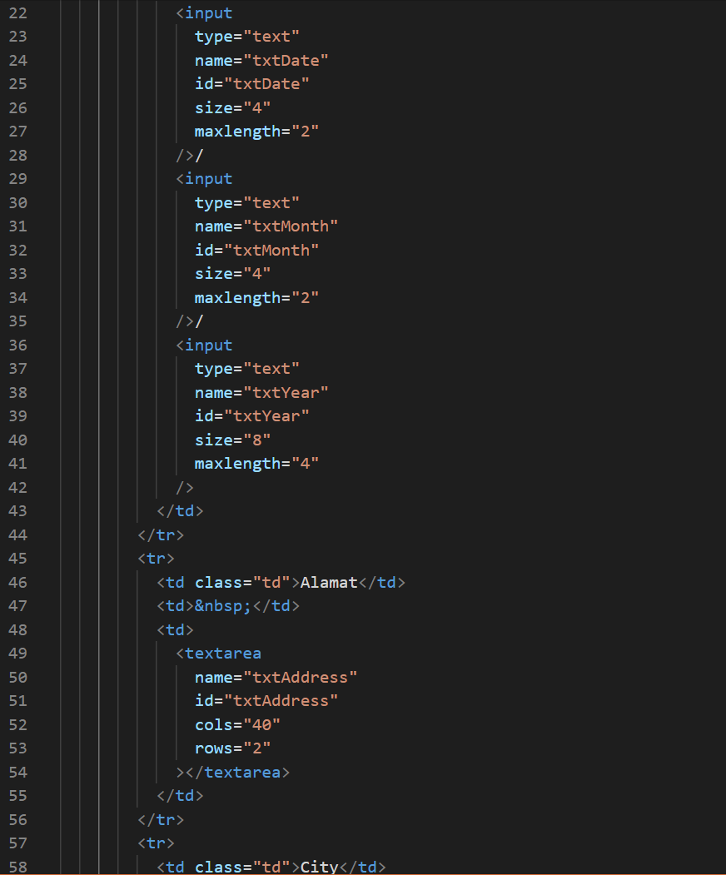

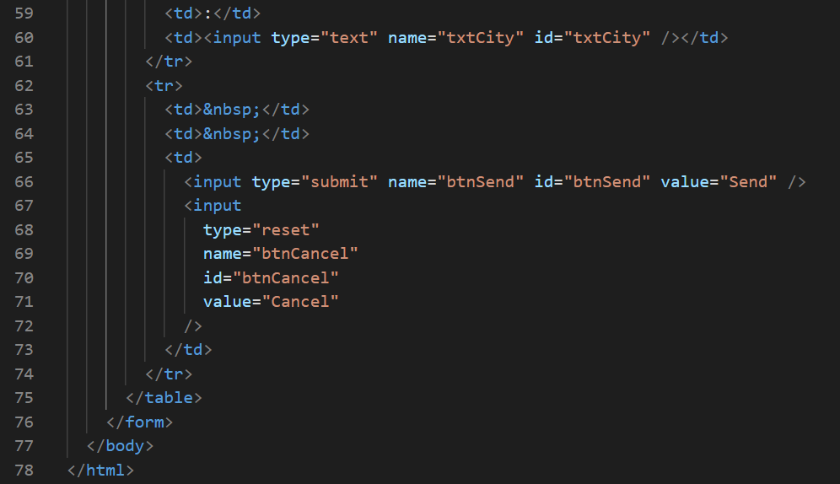

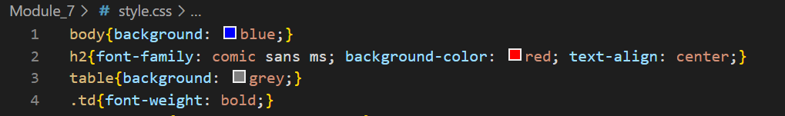

Picture 5.1 the code.

(Explanation)

This HTML code displays a simple registration form with multiple inputs using a table for organization. The form has several input fields, including a name (`txtName`), a date of birth consisting of three separate inputs for the day, month, and year (`txtDate`, `txtMonth`, `txtYear`), an address (`txtAddress`), and a city (`txtCity`). The "Send" button (`btnSend`) is used to send the data to the `process.php` file via the `POST` method, while the "Cancel" button (`btnCancel`) is used to reset the form. The "Free Registration" title uses the `<marquee>` element, which makes the text move, although this element is considered obsolete in modern HTML standards. Additionally, there is a small error with the `cellpandding` attribute, which should be written as `cellpadding` to function correctly.

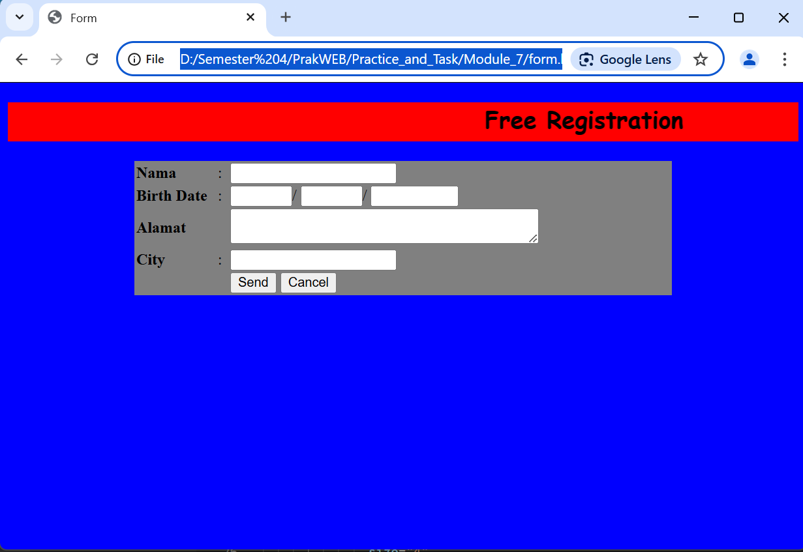

Picture 5.2 the output.

**ASSIGNMENT**

1. **Create a form border in experiment 5 using one of the border styles in eperiment 1 Write the script and attach the results that appear in the browser.**

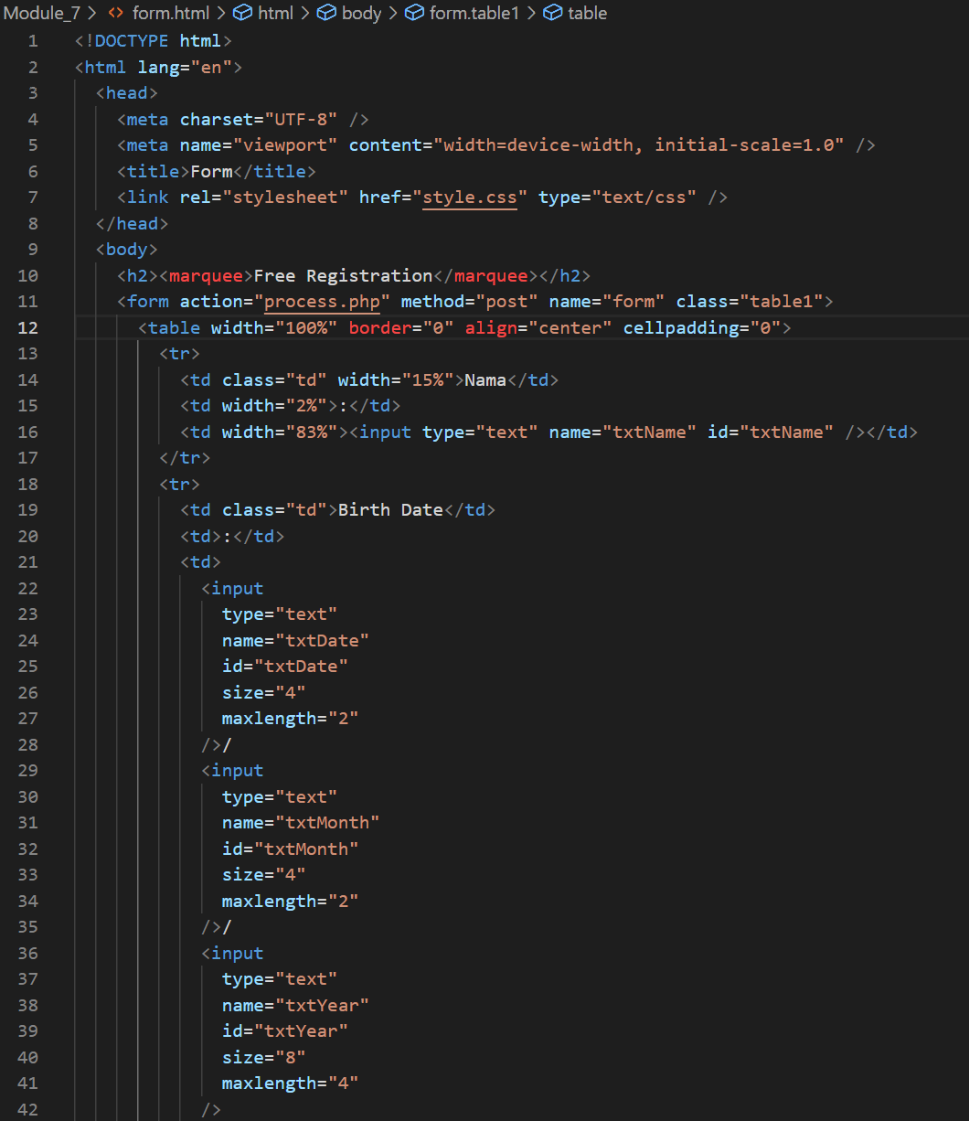

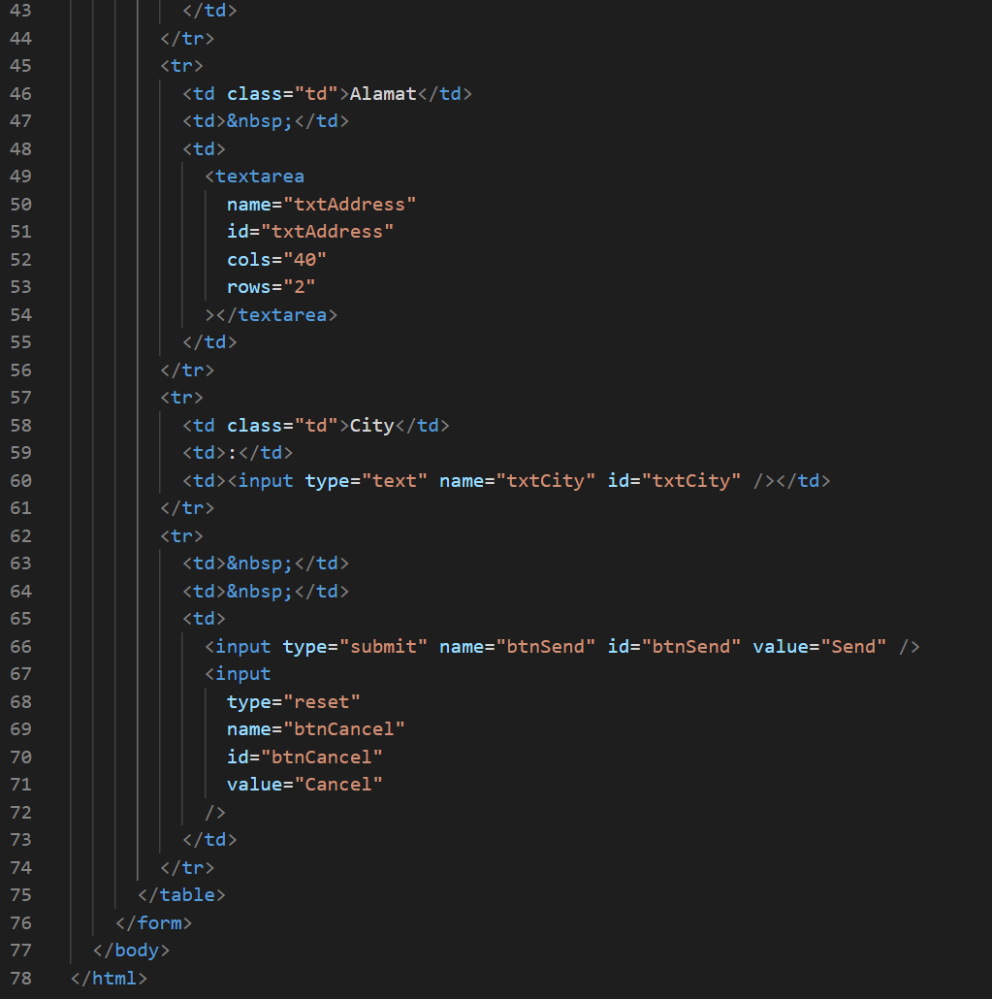

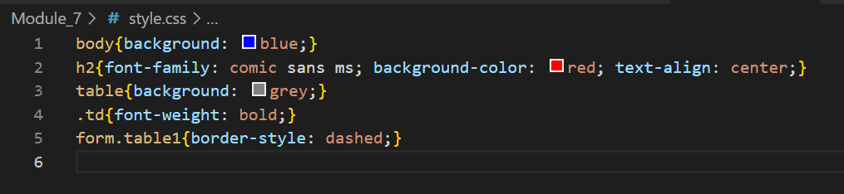

Picture 1.1 the code html and css

(Explanation)

This HTML and CSS code creates a simple registration form with a predefined design. The form uses a table (`<table>`) to position the inputs, with fields including name, date of birth (separated into day, month, and year), address, and city. In the `<style>` section, the page has a blue background (`background: blue;`), while the `h2` heading uses the *Comic Sans MS* font, has a red background, and is centered. The form has a dashed border (`border-style: dashed;`) with a gray table (`background: grey;`), and the text within the `<td>` is made bold using the `.td` class.

(Screenshot Output)

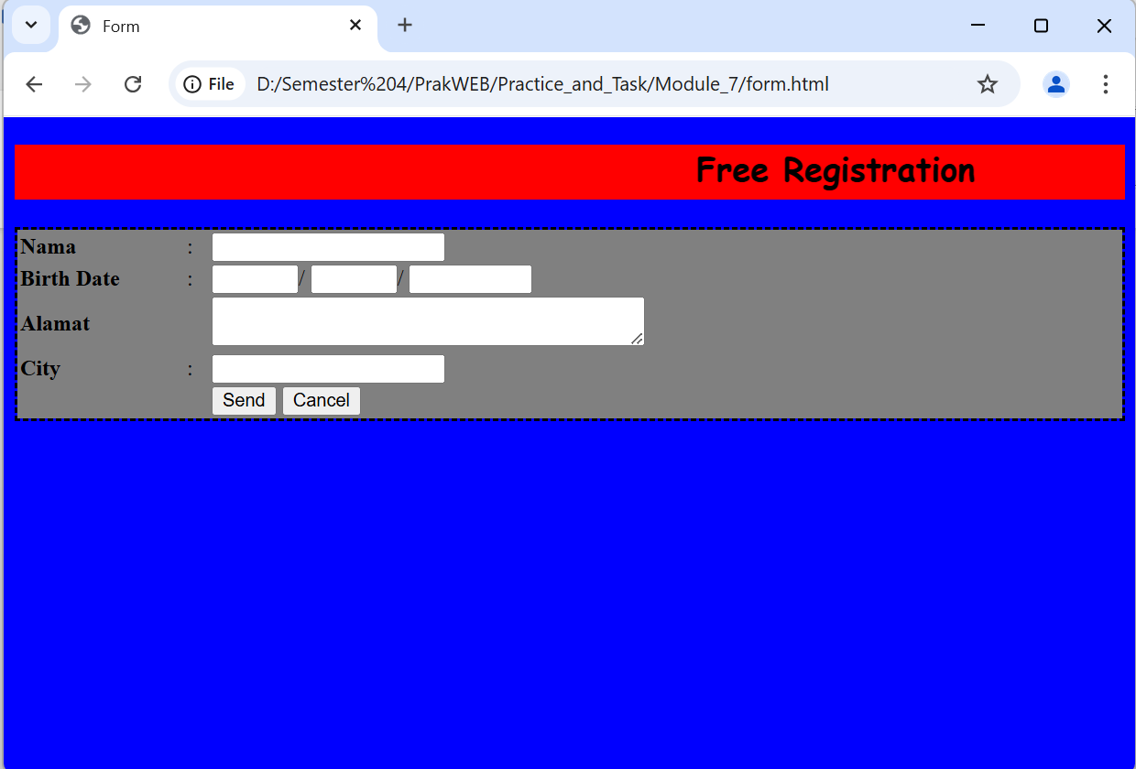

Picture 1.2 the output.